Hotel Reservation Form
Courtyard by Marriott Suwon
Next Generation Lithography + Patterning 2024 staying 11th Aug ~ 13th Aug 2024


320, Gwanggyohosugongwon-ro, Yeongtong-gu, Suwon, 16514, South Korea Phone: 82-31-267-6700 / Fax: 82-31-267-5601
For Reservation, Attention to Reservation manager Please e-mail to cy.selcw.reservation@courtyard.com Copy to ella.cho@courtyard.com

Personal Information
Reservation can be made up until 29st July 2024
Mr. / Ms. | Last Name: | Middle Name: | First Name:
Company/Organization: |  | Bonvoy Membership Number:
Work Phone:
Country code Area code Number
E-mail:

Itinerary & Room Reservation
Arrival(MM/DD/YY):  Estimated Arrival Time: (Check-in: 15:00) | Departure(MM/DD/YY): (Check out: 12:00)
ROOM RATE
Premier Room (All - Non Smoking rooms) Room Size : 28 ㎡
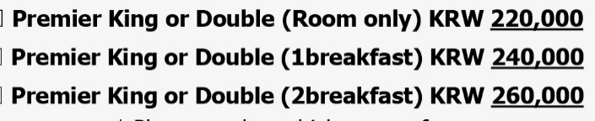

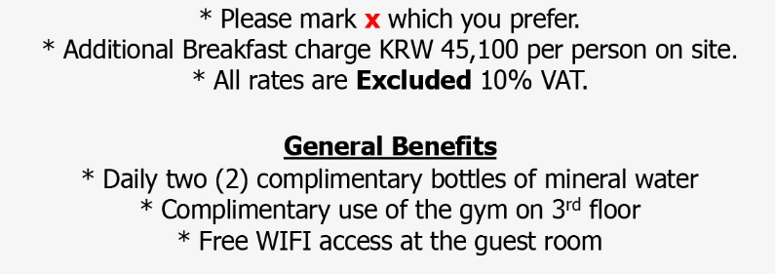

* Special request if necessary: | * Special request if necessary:

Please offer your credit card information to guarantee your reservation via E-sertifi link.
(*Link will be provided to insert your credit card information from reservation center via e-mail. Please fill it in the link to guarantee your reservation.)
Agreed for providing personal information to hotel | □Yes □No
Signature:
Please complete this form and return it directly to hotel by e-mail.
Contact Person | Phone | Fax | Email
Reservation | 82-31-267-6700 | 82-31-267-5601 | cy.selcw.reservation@courtyard.com

